**Name of the Project :**

Customised Virtual File System

**Technology Used :**

C++ Programming

**User Interface Used :**

Command User Interface

**Architectural Requirement :**

Intel 32 bit processor

**Description of the Project :**

File system is way of storing, representing the files in a particular formate. NTFS, FAT32, FAT 64, UFX are the type of file system. In file system create, rea, write, open, lseek, unlink commands are used in hard disk but int this project are file system all commands are virtual performing in the RAM. This project is Command User Interface. In this project we have to use C++ for platform independency.

**Data Structures used in the Project :**

Singly Linear Linked List

**After the code past screenshot of output which demonstrates every feature of our project separately :**

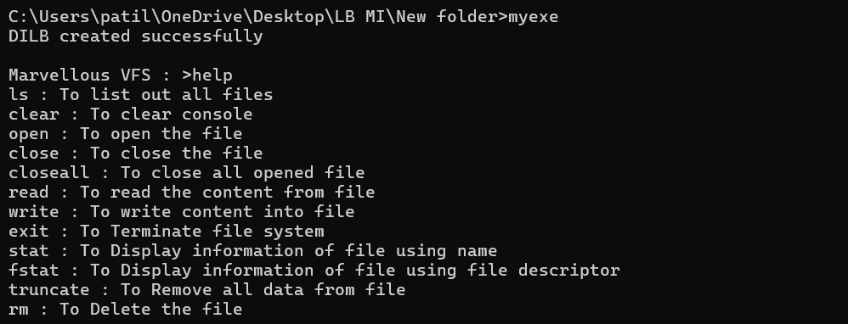

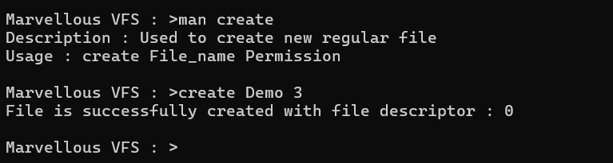

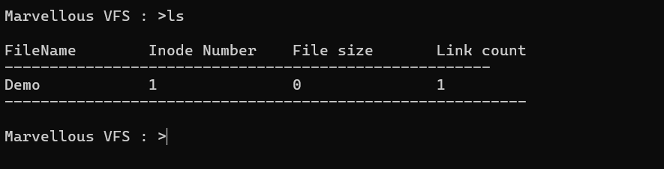

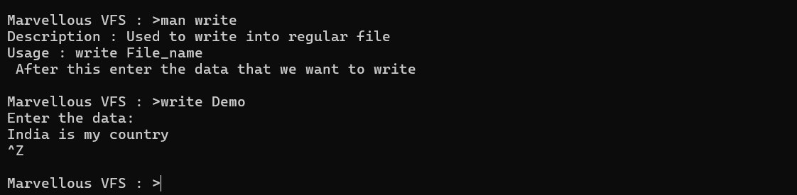

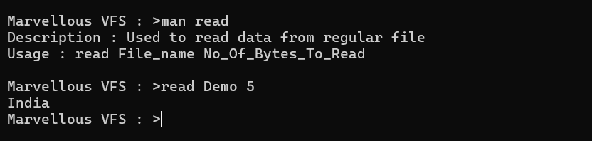

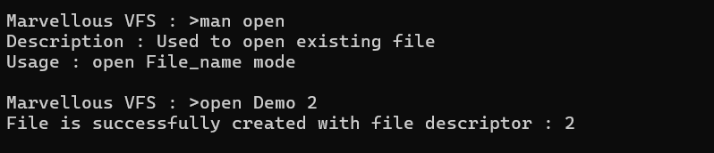

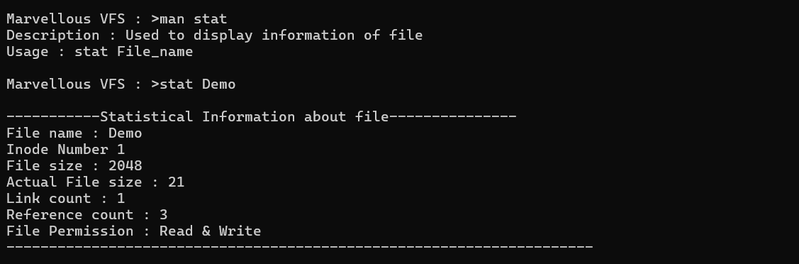

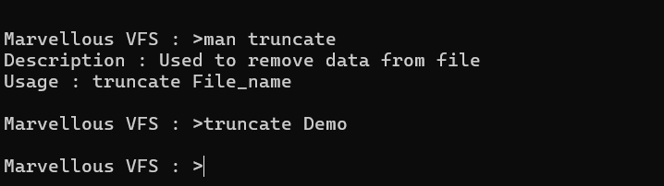

**Internal Working of below System calls :**

* **Open :** To open the files

syntax - open(File_Name , O_RDWR);

* **Close :** To close a File descriptor

Syntax – close(fd)

* **read :** Read from a file descriptor

syntax – read(fd, Arr, fd)

* **write :** Write to a file descriptor

syntax – write(fd , Arr, strlen(Arr))

* **lseek :** Reposition read/write file offset

**Commands :**

* **ls :** List directory contents
* **ls -l :** Use a long listing format
* **ls -a :** do not ignore entries starting with .
* **rm :** Remove files or directories
* **cat :** Concatenate files and print on the standard output
* **cd :** Change the working directory
* **chmod :** Change the access permission of files and directories
* **cp :** Copy files and directories
* **df :** Report file system space usage
* **find :** Search for file in a directory hierarchy
* **grep :** Print lines that match patterns
* **mkdir :** make directories or files
* **pwd :** Print name of current/working Directory
* **touch :** Change file timestamps and Create the Directories or files
* **uname :** get name and information about current kernel
* **stat :** get file status
* **man :** an interface to the system reference manuals
* **mkfs :** Build a Linux file system